Which bottled water advertisement is an Ethos appeal?

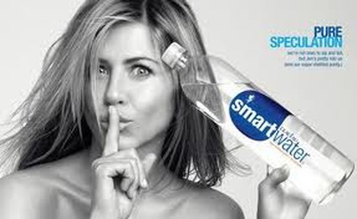
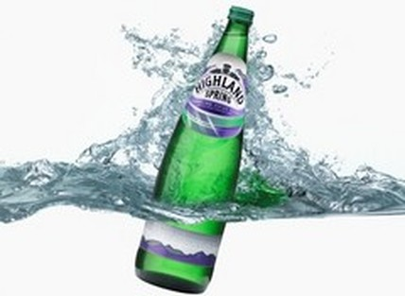

Answer:

Which advertisement is a Pathos appeal? Why?
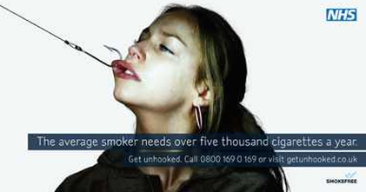

Answer:

Which advertisement is a Logos appeal? Why?
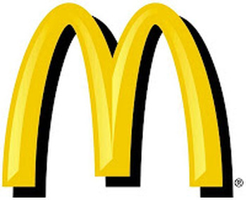

Answer:

Quick Write
What elements/devices in these advertisements are important to help us choose which appeal is being used?

